Patient Name:

Patient DOB:

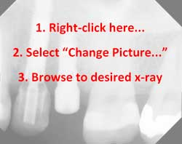
Date radiographs taken:
Comments:
Dr. Name
Address
City, State Zip
Phone number

